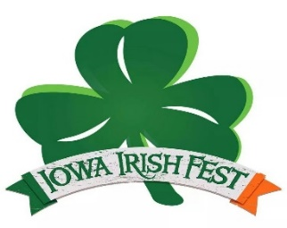
Iowa Irish Fest
August 5 – August 7, 2022
Deposit Fee $600.00/ After July 1st $700.00
- Proof of Liability Insurance, Must be turned in with application to be Accepted
Please Print
Vendor Name:
Contact Name:
Mailing Address:
City: State: Zip:
Cell# Home#
Email: IA Sales Tax#:
Standard Booth space is approximately 10 x 10
Space Size | Check-One | Pricing | Table Rental ($10 each) | Number tables Needed | Total
10 x 10 |  | Included
10 x 20 |  | $100 extra
10 x 30 |  | $200 extra
10 x 40 |  | $300 extra
20 x 20 |  | $400 extra
24 x 24 |  | $400 extra
No refunds after July 15th Money orders or cashier checks after July 1st.

Iowa Irish Fest 2022
Attn: Kathy McGowan vendors@iowairishfest.com (319)-290-0030
3754 Airline Hwy. West
Waterloo, Iowa 50703
WAIVER OF LIABILITY: (Must be signed to enter) In consideration of the Iowa Irish Fest Committee accepting this entry, I, the undersigned, intending to be legally bound, hereby, for myself, my heirs, executors, and administrators, waive and release any and all rights and claims for damages I may have against the Iowa Irish fest committee, their agents, successors, and assigns for any and all injuries suffered by me or my team in this event. Further, I hereby grant full permission to Iowa Irish Fest and or their authorized agents to use any photographs, videotapes, recordings or any other record on this event for any legitimate pose. I agree to abide by all contest rules set out by Iowa Irish Fest.
Signature: Date:
IIF Office Use Only: Date Received Amt. Received CK# Ins. Info_ Initials______

