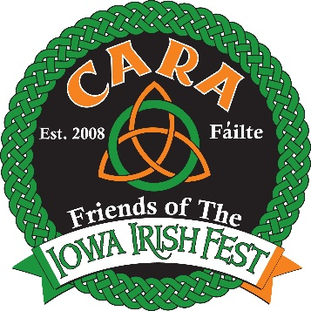Want To Be A Friend of the
Iowa Irish Fest?

Join Cara!!!

Become a Cara, Friend of the Iowa Irish Fest, and support the Cedar Valley’s vibrant Irish culture year-round. As the ongoing social group, we engage in multiple activities that promote Irish culture and comradery.

Notable Cara Points
- We support the Iowa Irish Cultural Association’s goal to celebrate and develop Irish fellowship, outreach and pride in our community.
- We create opportunities to enjoy the company of others who value the Irish culture.
- We offer you the opportunity to help sponsor new bands to our Fest.
- We hold annual events including St. Practice Day in February, an Irish Fest Ticket event in May, a fall bus trip in October and a Christmas party at Jameson’s in December
- We sponsor day long trips/activities

Yes, I __________________________ (name*), want to be a Cara member of the Iowa Irish Fest!
*your name as you would like it to appear in the program
Address: ______________________________________________________________

Phone #: ______________ Email: _________________________

My preferred method of contact is Text______Email______US Postal Service_______

___Harp* - $30 One weekend pass
___Shamrock*- $60 Two complimentary weekend passes
___Leprechaun*- $150 Four complimentary weekend passes
___Pot of Gold*- $280 Six complimentary weekend passes
___Over the Rainbow*- $550 Eight complimentary weekend passes
*Membership also includes: acknowledgement at Irish Fest & invitations to Cara sponsored events

Please make checks payable to: Iowa Irish Fest
*Return upper portion and payment by mail to;
Cara Membership, c/o John Vaughan, Sr., P. O. Box 736, Hudson, IA 50643

----------------------------------Your Receipt below, Keep for your records ---------------------------------------
We look forward to seeing you at the Iowa Irish Fest! Thank you for your support!

Date: __________________

Membership: $___________ _____ Check _____ Cash

John Vaughan, Sr., P. O. Box 736, Hudson, IA 50643
CARA.iif@gmail.com
Cedar Valley Irish Cultural Association, Inc.
www.IowaIrishFest.com

